The THIS-Crowd Exclusion Study

Frequently asked questions

What is this task?
This task forms part of a methodological study that we (Cochrane Crowd) are doing in collaboration with The Healthcare Improvement Studies Institute (THIS Institute). The aim of the study is to evaluate the effect of asking contributors to exclude the records that they are sure are not relevant to the topic. Normally, we ask you to assess a record for its potential relevance to the topic in question. It’s a subtle difference but one that we think might help to ensure that no relevant records are incorrectly rejected.

How is this methodological study designed?
We are running this methodological study as a randomised controlled trial. A randomised controlled trial is way of conducting an experiment. In this randomised trial we are randomizing participants to one of three different groups. All three groups of participants in this trial will perform the same screening task. The difference between the groups is agreement algorithm we will be using for each. The agreement algorithm is simply the number of agreeing classifications or decisions needed on a record for the final decision to be automatically generated.

What support or guidance is there for me to do the task I’m assigned to well?
There is a mandatory training module. The training takes you through everything you need to know and will take around 15 minutes to complete. There is also a Quick Reference Guide that will be accessible from the task itself.

How can I join the study?
Hopefully very easily! Just go to Cochrane Crowd: https://crowd.cochrane.org and head to the tasks page. You should then be able to see the task. It will look like this:

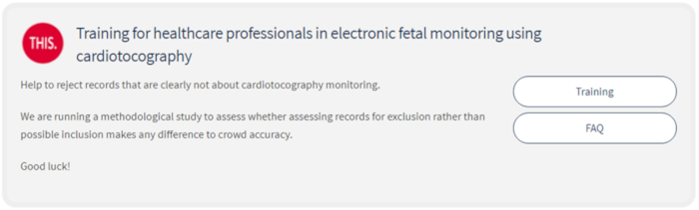

Once you click on the Training button, the system will randomise you (so exciting!). You won’t notice anything different. You will then need to complete the training module. You need to get 12 or more correct out 15 to progress to the live records. However, don’t panic, you can re-take the training as often as you like.

What if I join the study but then decide I don’t want to do it after all?
If you sign up and then find you don’t want to do this after all, or you simply don’t think you have the time, then that is absolutely fine. You don’t need to feel bad or to notify us. We expect that some will sign up and then realise that actually it’s not for them after all.

How long will this task be around for?
This task will be live for three weeks, but if all the records are screened before the three weeks is up, we’ll close it early, or if we need more time, we will extend it.

What do I get out of this?
You can earn a certificate issued on behalf of Cochrane and THIS Institute, and named acknowledgement in the write-up of this study for those who assess 250 or more records.

What information will be shared with THIS institute?
We will share fully anonymized screening decisions made for this task as well as metrics around the number of citations screened, time taken, classifications made, number/proportion of disagreeing classifications requiring resolution.

Can I feedback my thoughts?
We will be sending out a brief survey at the end of this pilot exercise where you will be able to feedback your thoughts. However, if you have any questions, queries or suggestions in the meantime please don’t hesitate to email either Anna at anna.noel-storr@rdm.ox.ac.uk.

